WIKIPEDIA ACCOUNT CREATING CREATING PAGE AND EDITING IT.

1. What is Wikipedia?

Wikipedia is a free, web-based encyclopedia project which contains information on a wide variety of subjects which are added by contributors from all over the Internet. It is website that provides free information in many languages on many subjects, and can be changed or added to by anyone. There are experts who watch for errors, and pages on which disagreements about subjects can be discussed.

|  |  |
| --- | --- |
| Wikipedia    i | |
|  | |
|  | 21-02-2022 |

1. Creating an Account.

Step 1) Click the create account" link in the upper right corner on the

|  |  |
| --- | --- |
| village accountant •Séarch x •Wikipedia * + | |
|  | |
|  | Z'.02-2022 |

Wikipedia website

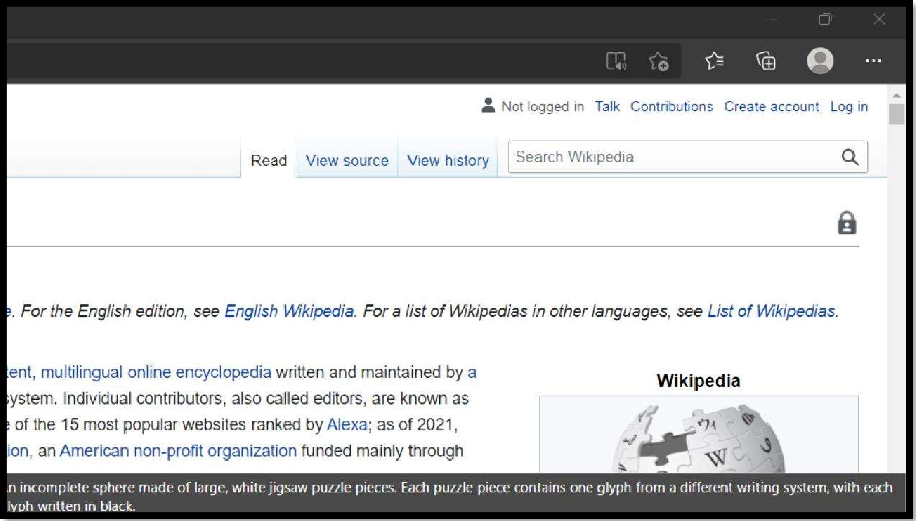

Step 2) : This will take you to the account creation page.

Step 3) after clicking there; fill in your credentials that are asked

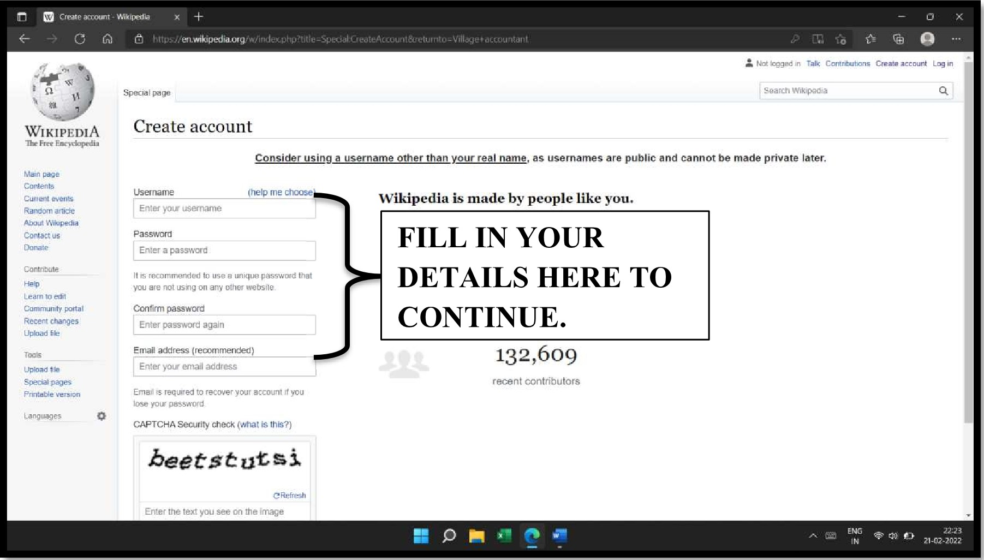

Step 4)Click the big "Create account" button.

|  |  |
| --- | --- |
|  | mal a ress (recommen e ) 132,  o  Enter your email address |
| recent contribut Email is required to recover your account if you lose your password.  CAPTCHA Security check (what is this?)       |  | | --- | | beetséutsi | | Enter the text you see on the image | |

Step 5) after your account is created

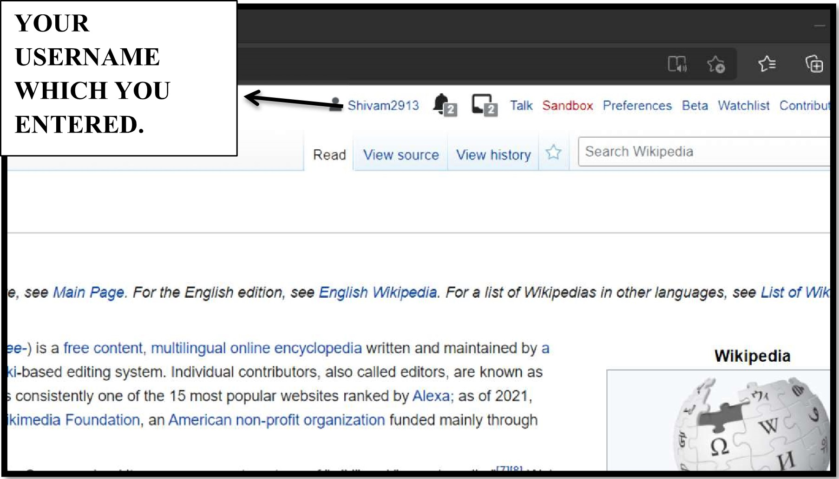

1. Creating Your Page.

Step 1) Click on this sandbox option.

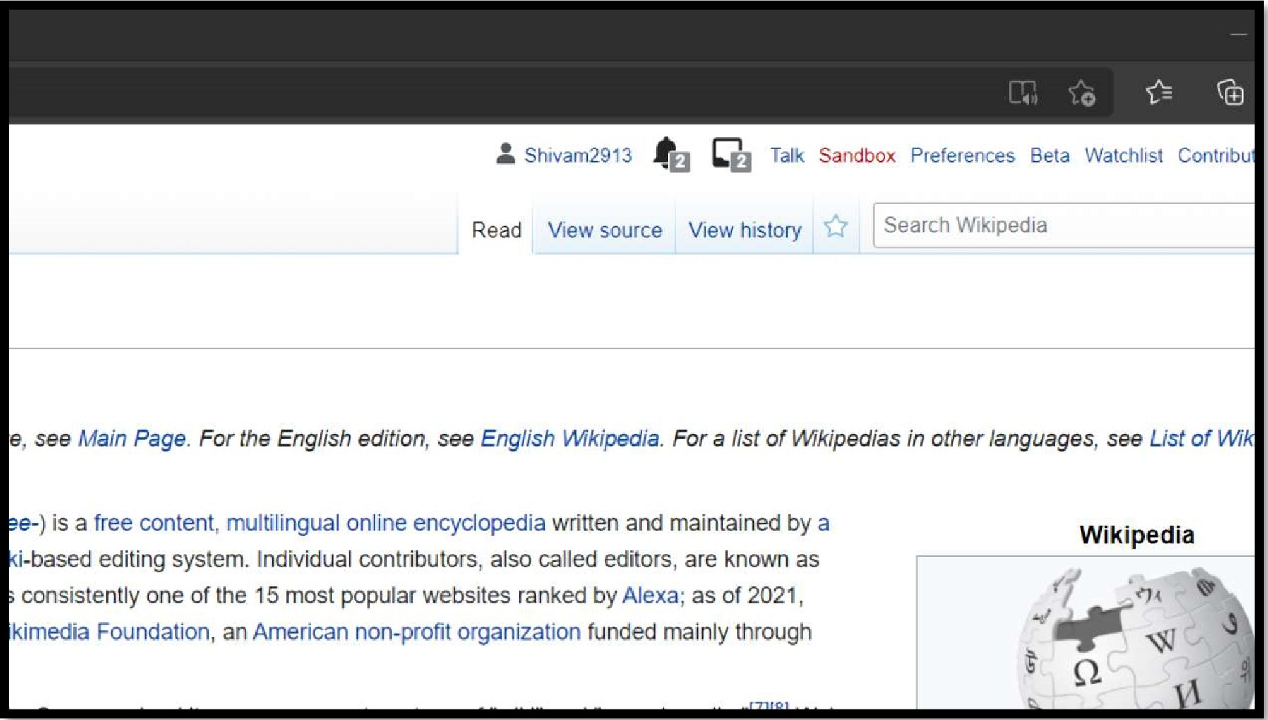

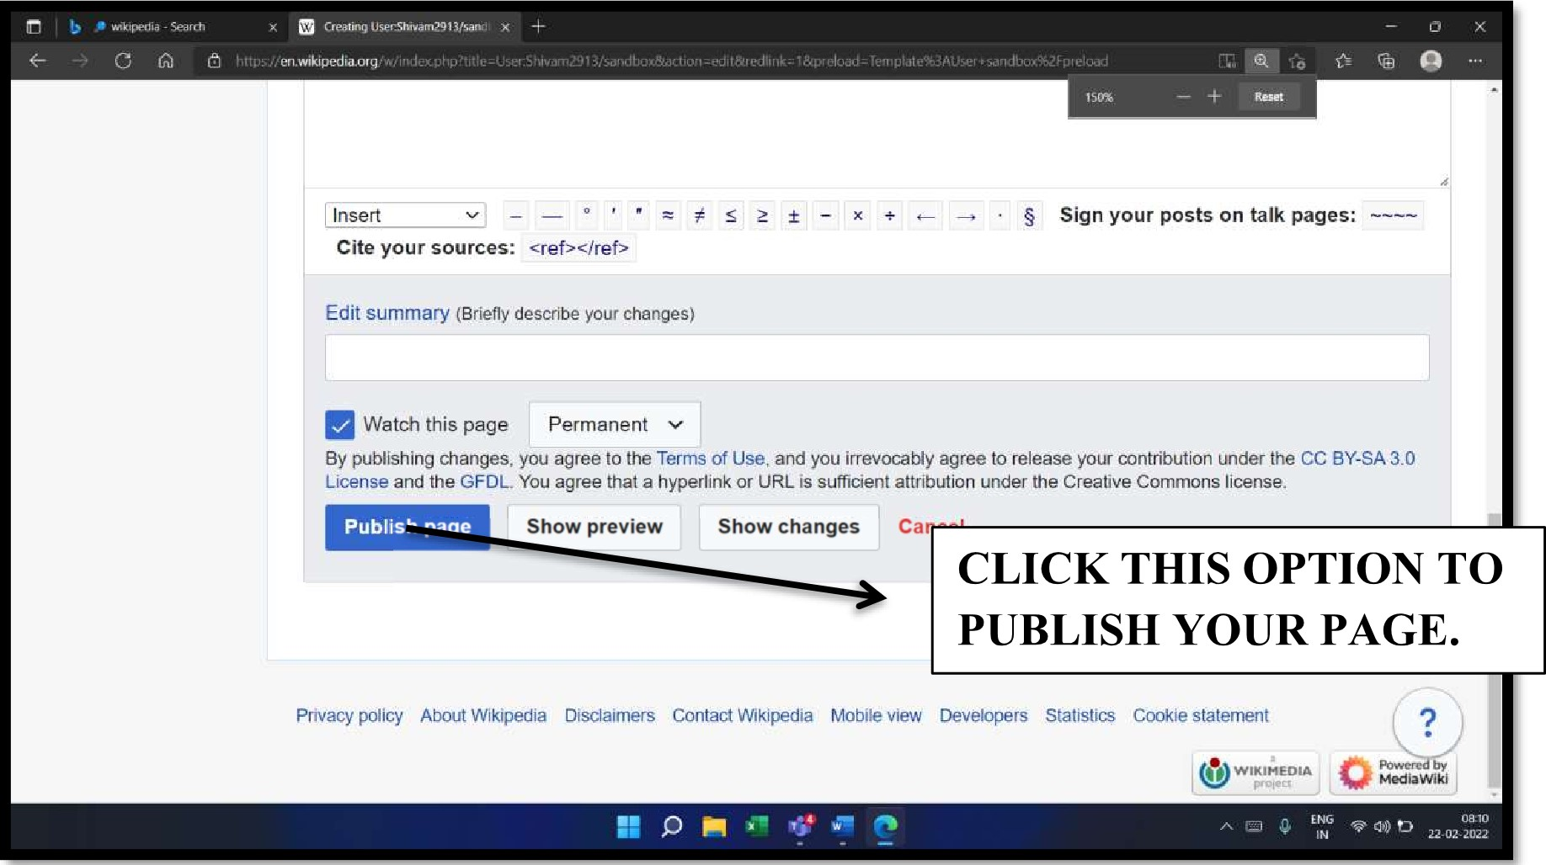Step 2) after that, you will see this page where you will be able to write content in your page.

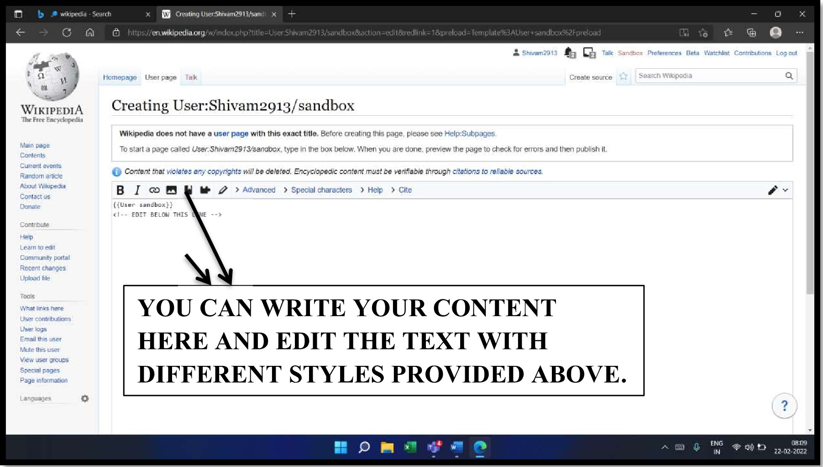

Step 3) after getting finished with the content, click on the publish page option to publish your page online.

Step 4) Click on "Submit your draft for review" option if you have created a draft

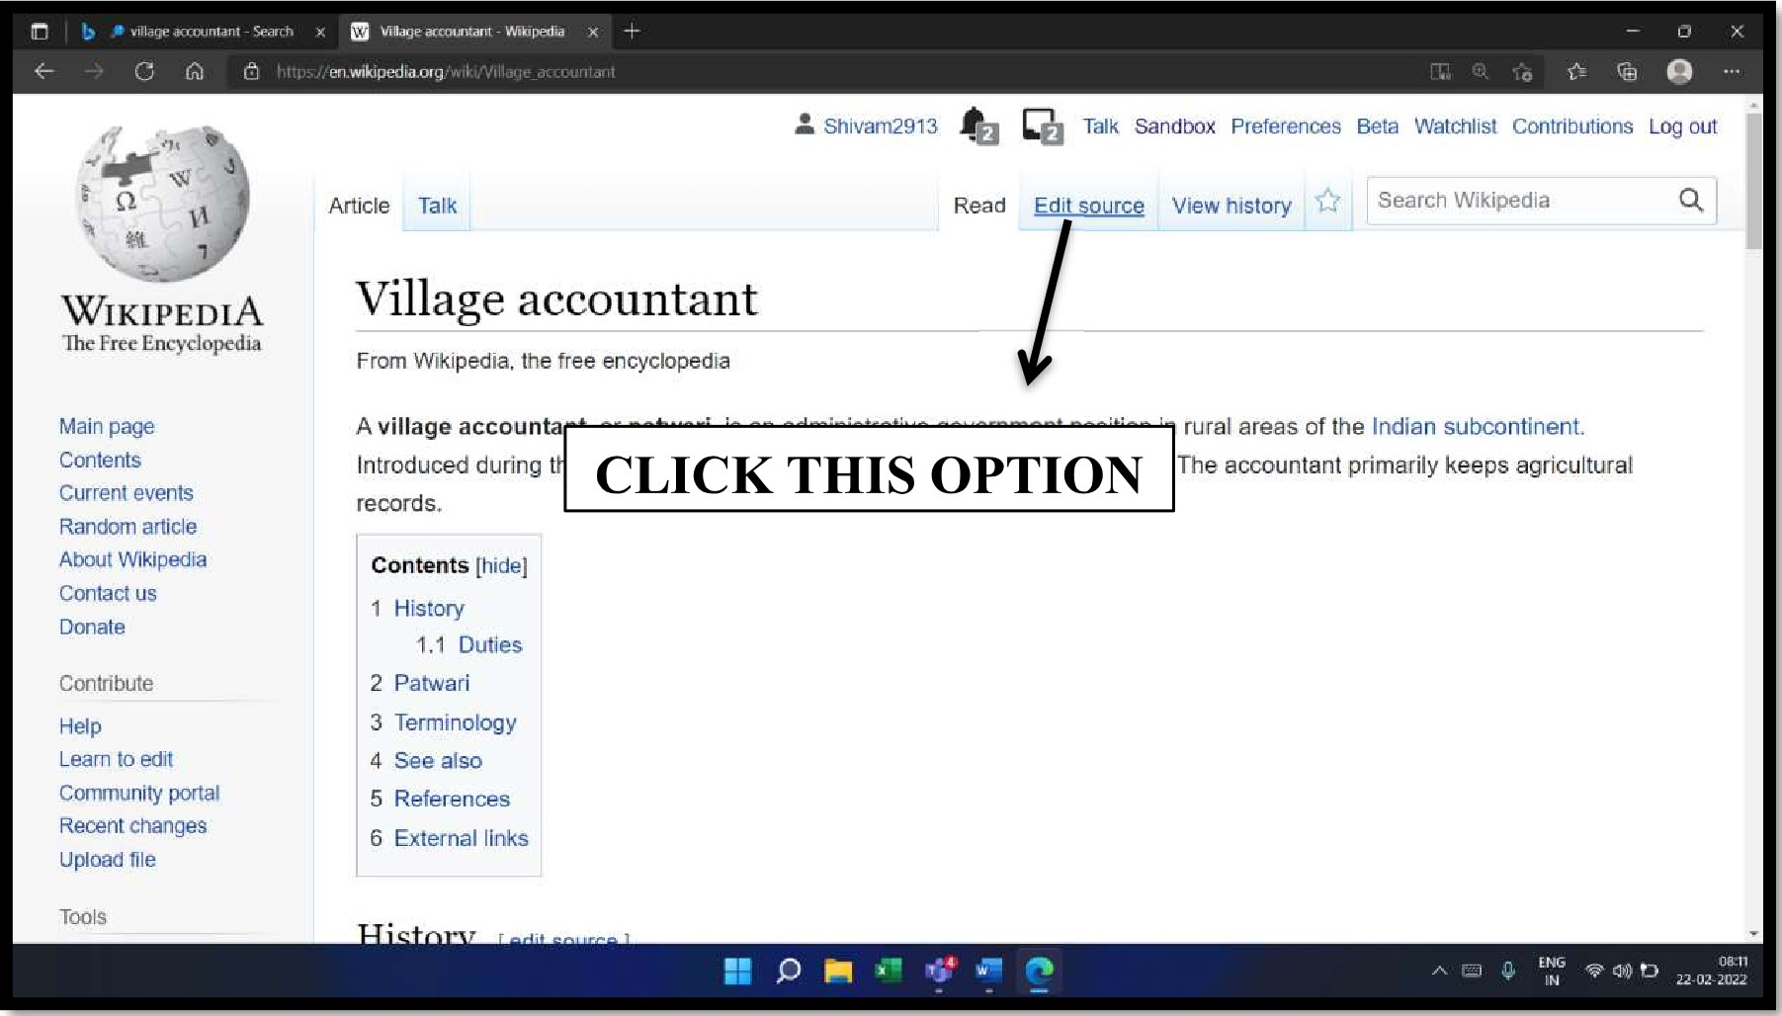- Search

|  |  |  |
| --- | --- | --- |
|  | €1 htt05W/en.wikipedia.org/uwik1fl.J5erShwarnZ.€11 3J5endbox  Sandbox Pra'etences geta Watchiise Contributions Log out  Homepage User page Taik Read Edit source, history •k Seam-h | |
| WIKIPEDIA | User:Shivam2913/sandbox | |
| Free | From | the tree encycgc.pedi*  TnlS is the user sandbox or Shivan•agla. A user sanr:nox IS a subpage ot me usersuser page, It serves as a testing spot and page development space |
| CUtient events |  | tor the user and is not an encyclopedia article. C-teate or edit your rtete. |
| Random a Niete A,bgui Wik.pedla |  | Other sandboxes: Main I Template sandbox |
| Contact  Contn  Leam 10 edii |  | Finished writing a dratt article? Are you ready to request an experienced editor review it (Or possible inciuslon in Wikjpedia?  Sumtit your reun |
| Cammumt',• | This page | edited on 22 February 2022, at 4 |
| Recent | Text is available | the Creative C„ornrnons CLICK HERE TO the Terrns•af use and Privacy Policy IS registered trademark the Wikimedia |
| LJpbad | Founda•bon, . non-profit or *nZAtion  Prrg•.cy policy Wikipedia Disclaimers SUBMIT | |

Retaled changes user

User logs

Email this us,ev

Mute user

P ink

Page

22-02-2022

1. Edit your page

Step 1) To edit your page content click on the edit source option and edit your content.

Step 2) A page like below will appear where you can edit your content and republish it.

